**Marketing Strategies Of A Software Development Company**

**What is Global Expansion?**

Global expansion refers to a company moving from their home market, or local market, into international markets. It’s a great opportunity for any company that’s looking to expand their operations and capture a wider market share.

Expanding a business internationally provides companies with access to additional markets. Entering new markets helps businesses grow beyond the customers and prospective buyers in their original country. A worldwide market means more potential buyers, markets with different needs and preferences, and markets operating within different regulatory requirements.

Generally, companies expanding globally follow one of these 4 key global expansion strategies:

* [International strategy](https://phrase.com/blog/posts/international-strategy/)
* Multi-domestic strategy
* Global strategy
* Transnational strategy

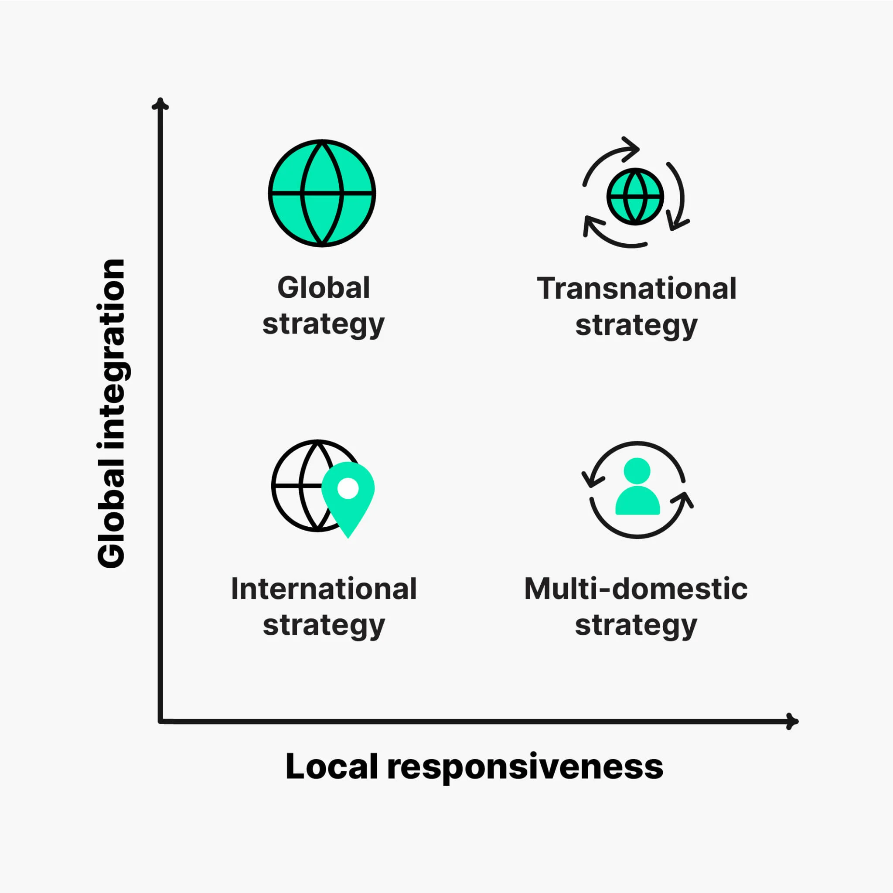

**What is the Capex Light Business Model?**

An asset-light business model will help entrepreneurs to grow by investing only one-fourth to one-third of the capital that would usually be required. The idea of an asset-light and investment-friendly business model is to keep the capital assets less in comparison to the operations.

An asset-light company can expand its reach to a new location at the simple click of a button and increase the number of partners in its network. Some of the other advantages of the asset-light business model are as follows:

* The costs of investment and running the Asset-Light Business Model business is less, and revenue and profits would be more.
* Start-ups can own the operational part of the company and outsource any other assets needed.
* They confer greater flexibility to tech-enabled new-age businesses to scale up much faster than traditional asset-heavy industries. This quick scalability gives them a definite edge over others in the market.
* The startup can grow new assets and sell them later at a profit.
* Businesses with high scalability and lower capital requirements are more attractive to equity investors. So, it will help entrepreneurs to get the company listed.

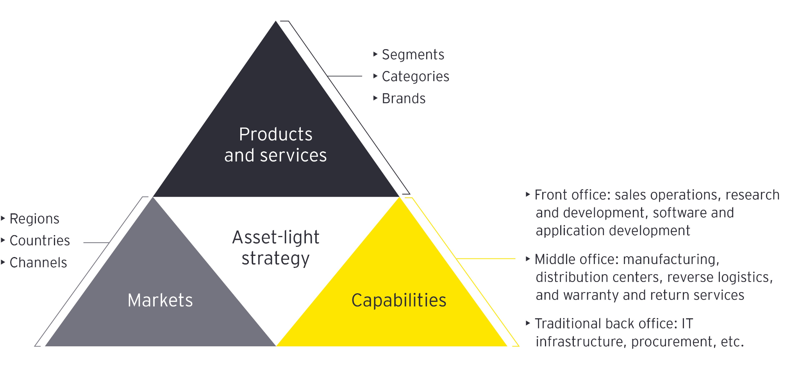

**Growth Of Digital Market In UK and US**

Data shows that overall digital marketing spending in the UK is £25.84 billion. Although the growth rate slowed down compared to **36.1%** in 2021, it still is a significant growth in digital marketing budgets overall. Pandemic had a vast impact on digital marketing; it boosted the industry by 20%. A lot of people also started using mobile devices for organic search on google and with everything shifting virtually the demand for new softwares rose significantly.

It was reported that 63% of organic searches on Google in the second quarter of 2021 came from a mobile device. Plus, mobile devices accounted for 55% of the global market share, with desktop following behind at 42%.

Alternatively, it appears that social media ads may be the more effective option depending on who your target demographic is. 49% of consumers ages 18-29 have reported making a purchase after first seeing a product in a social media ad.



**Market Penetration Strategies**

Once a company decides to target a particular country, it must choose the best mode of entry for its brands. Its broad choices are indirect exporting dint exporting, licensing, joint ventures, and direct investment.

**Joint Ventures**

Just doing business in another country may require the firm to license its product, form a joint venture with a local firm, or buy from local suppliers to meet "domestic content requirements Many firms have developed global strategic networks, with victory to those who build the better one. The Star Alliance brings together 28 airlines-including Lufthansa, United Airlines, Singapore Airlines SAS, and Avianca-in a huge global partnership that enables travelers around the globe to make nearly seamless connections to hundreds of destinations, Historically, foreign investors have often joined local investors in a joint venture company in which they share ownership and control.

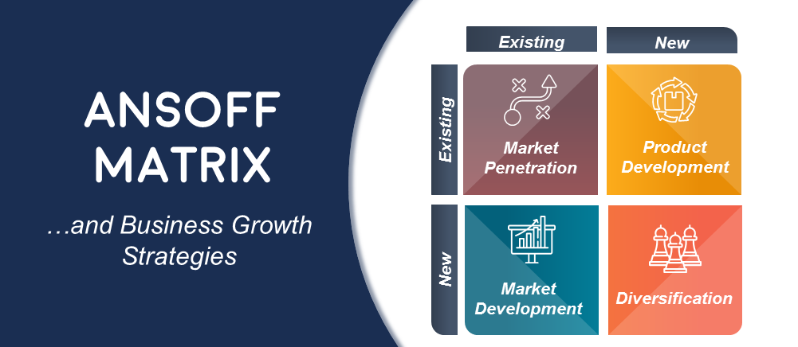

**Marketing Strategies for new Market Entrants**

1. **Collaboration with local marketing firms**

As local marketing firms know the market well since they are established there itself from the beginning of the journey.For a new company to settle in from scratch requires resources, labor, , capital and which won't suffice the Capex light model. Hence to generate a productive and efficient company business model in foreign place.

Thus it will save a lot of money for the company as they won’t have to invest a lot in market research and marketing. It is also a very great growth opportunity as they will be able to reach the desired customer base.

Companies such as izea, flex digital and noise media has their roots in both the nations UK and US and thus it will be easy to manage the work and the process will be very smooth.

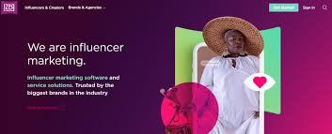

1. **Influencer Marketing**

Getting in touch with some famous influencers can build a very vast network as after pandemic the growth in social media marketing has increased significantly and a lot of people has started social media marketing.

An influencer marketing strategy leverages digital creators who strongly influence specific industries or target audiences to make purchase decisions. With a successful strategy, you can partner with these individuals to promote your brand, products, and services through curated messaging.

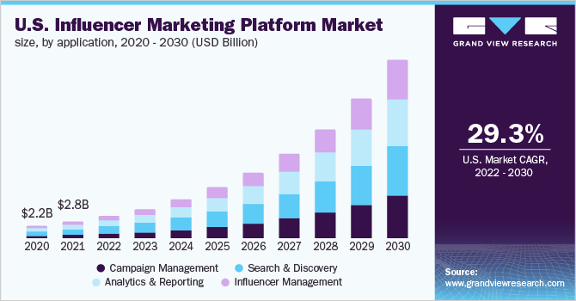

1. **COMPANY WEBSITE**

Companies must design websites that embody or express their purpose, history, products, and vision-and that are attractive on first viewing and interesting enough to encourage repeat visits Beauty pioneer Estée Lauder in a reflection of times gone by, famously said she relied on three means of communication to build her multimillion-dollar cosmetics business-telephone, telegraph, and tell a woman." She would now have to add the internet, where the company's official site describes new and old products, announces special offers and promotions, and helps customers locate stores where they can buy Estée Lauder products. Visitors will judge a site's performance on ease of use and physical attractiveness.

1. **DRIVING ONLINE TRAFFIC**

An important component of online marketing is driving traffic to the company's own media. There are two common approaches to drive traffic search engine optimization and search engine marketing.

Search engine optimization (SEO) describes activities designed to improve the likelihood that a link for a brand ranks as high as possible in the order of all unpaid links when consumers search for relevant terms. Because SEO involves optimizing the company's own website without paying a third party to generate traffic, it is significantly less costly to implement than search engine marketing Search engine marketing (SEM) describes activities whereby the company pays search engine companies to be featured in the results of particular keyword searches that serve as a proxy for the consumer's product or consumption interests. When consumers search for any of these words with Google, the marketer's ad may appear above or next to the results, depending on the amount the company bids and an algorithm the search engines use to determine an ad's relevance to a particular search. For example, McDonald's might pay Google for its information to appear among the results generated when consumers search for a particular word or phrase, such as "burger," "French fries," or "fast food." Advertisers typically pay only if people click on the links, but marketers believe consumers who have already expressed interest by engaging in search are prime prospects. The cost per click depends on how high the link is ranked on the page and the popularity of the keyword. The ever-increasing popularity of paid search has increased competition among keyword bidders, significantly raising search ad prices and putting a premium on choosing the best possible keywords, bidding on them strategically, and monitoring the results for effectiveness and efficiency.

1. **Marketing through Blogs**

Blogs, regularly updated online journals or diaries, have become an important outlet for word of mouth. There are millions in existence, and they vary widely, some are personal for close friends and families, and others are designed to reach and influence a vast audience. One obvious appeal of blogs is that they bring together people with common interests. Corporations are creating their own blogs and carefully monitoring those of others." Because many consumers examine product information and reviews contained in blogs, the Federal Trade Commission has also taken steps to require bloggers to disclose their relationship with marketers whose products they endorse. At the other extreme, some consumers use blogs and videos as a means of getting retribution for a company's bad service or faulty products.

1. **Social Networks**

Social networks such as Facebook, LinkedIn, Instagram, YouTube, Twitter and WeChat have become an important force in both business-to-consumer and business-to-business marketing. Marketers are still learning how best to tap into social networks and their huge, well-defined audi- ences. Given networks' noncommercial nature-users are generally there looking to connect with others-attracting attention and persuading are challenging. Also, given that users generate their own content, ads may appear beside inappropriate or even offensive material. Much online content is not necessarily shared and does not go viral. Only a small fraction of content ends up "cascading" to more than one person beyond the initial recipient. In deciding whether to contribute to social media, consumers can be motivated by intrinsic factors such as whether they are having fun or learning, but more often they are swayed by extrinsic factors such as social and self- image considerations.25 Harvard Business School viral video expert Thales Teixeira offers the following advice for get- ting a viral ad shared. Utilize brand pulsing: Display the brand for short periods of time in a way that doesn't make the brand too intrusive within the story, open with joy or surprise to hook those fickle viewers who are easily bored, build an emotional roller coaster within the ad to keep viewers engaged throughout, and surprise but don't shock; if an ad makes viewers too uncomfortable, they are unlikely to share it.

1. **Customer Reviews**

Customer reviews can be especially influential in shaping customer preferences and buying decisions." One Nielsen survey found that online customer reviews were the second most trusted source of brand information (after recommendations from friends and family). Research has shown that social influence can lead to disproportionately positive online ratings, and subsequent raters are more likely to be influenced by previous positive ratings than by negative ones. Consumers posting reviews are susceptible to conformity pressures and to adopting the norms of others." On the other hand, positive online reviews or ratings are often not as influential or valued as negative ones.Consumers are also influenced by the online opinions and recommendations of other consumers.The informal social networks that arise among consumers complement the product networks set up by the company "Online "influentials who are one of a few people-or maybe even the only person-to influence certain consumers are particularly important and valuable to companies.

1. **Groupon**

Groupon was launched in 2008 to help businesses leverage the internet and e-mail to use promotions as a form of advertisement. Specifically, the company sends its large base of subscribers a humorously worded daily deal-a specific percentage or dollar amount off the regular price-for a specific client's branded product or service. With these e-mailed discounts, Groupon offers client firms three benefits: increased consumer exposure to the brand, the ability to price-discriminate, and the creation of a "buzz factor." Groupon takes 40 percent to 50 percent of the revenues in each deal in the process. Many promotions are offered on behalf of local retailers such as spas, fitness centers, and restaurants, but Groupon also manages deals on behalf of some national brands. Some businesses have complained that Groupon attracts only deal-seekers and is not effective in converting them to regular customers. One study found that 32 percent of companies lost money and that 40 percent said they would not utilize such a promotion again, with restaurants faring the worst among service businesses and with spas and salons being the most successful. Groupon has tried to innovate in several ways. Leveraging its massive sales force to sell Groupon Now, the company enlists local businesses to offer time- and location-specific deals via the Web or smartphones. The iPhone app for the new service has two buttons, "I'm Bored" and "I'm Hungry," to trigger deals in real time. For businesses, the service is a way to boost traffic at otherwise slow times. Even a popular restaurant might still consider some midday and mid-week discounts, knowing it is rarely full then. After a hyped IPO, Groupon's stock has not performed well and the company is still struggling to find the right business formula."

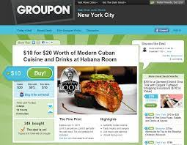

**Deciding on the Global Marketing Program**

International companies must decide how extensively to adapt their marketing strategy to local conditions. At one extreme is a standardized marketing program worldwide, which promises the greatest consistency across individual countries. At the other extreme is an localized marketing program in the company, consistent with the marketing concept, believes consumer needs vary and tailors its marketing to each target group. Oreo cookies offers a good example of the latter strategy. Having a standardized marketing program offers multiple advantages. These include economies of scale in production and distribution, lower marketing costs, consistency in brand image, ability to leverage good ideas across different markets, and uniformity of marketing practices. At the same time, having a standardized marketing program has several drawbacks. It ignores differences in area: such as the customer needs, wants, and usage patterns for products; customer response to marketing programs and activities; the different competitive environment; and the specifics of the legal, cultural, and political context.

